**Lab 2**

**Basic DOS Functions**

**Functions for take input.**

01= for single character

3fh= for string input

1. Create a program which take input from user.

.model small

.stack 100h

.data

.code

Start:

Mov ah, 01

Int 21h

Mov ah, 4ch

Int 21h

End start

1. Create a program which take input and print it on output screen.

.model small

.stack 100h

.data

.code

Start:

Code for input

Mov ah, 01

Int 21h

Mov ah, 02

Code for print input character

Mov dl, al

Int 21h

Mov ah, 4ch

Int 21h

End start

1. Create a program which takes input a character from user and print it on new line.

. model small

. stack 100h

.data

. code

Start:

Code for input

Mov ah, 01

Int 21h

Input will save in al register by default

So here we save al data in bl register

Mov dl, al

0Ah is function which is used for line feed

Mov ah,02

Mov dl, 0AH

Int 21h

0DH is used for carriage Return

Mov ah,02

Mov dl, 0DH

Int 21h

Code for print inputed Character

Mov ah,02

Mov dl, bl

Int 21h

Mov ah, 4ch

Int 21h

End start

1. Take string as an input from user.

.model small

.stack 100h

.data

.code

Start :

Mov ah, 3fh

Int 21h

Mov ah, 4ch

Int 21h

End start

**Task**

Q. Search about different function and try to use in code.

The below code is write using different function.

Q create a code for given output

***********

A

A

**********

**Source Code:**

.Model small

.stack 100h

.code

start:

Mov ah,02

Mov dl,'*'

int 21h

Mov ah,02

Mov dl,'*'

int 21h

Mov ah,02

Mov dl,'*'

int 21h

Mov ah,02

Mov dl,'*'

int 21h

Mov ah,02

Mov dl,'*'

int 21h

Mov ah,02

Mov dl,'*'

int 21h

Mov ah,02

Mov dl,0AH

int 21h

Mov ah,02

Mov dl,0DH

int 21h

Mov ah,01

int 21h

Mov bl,al

Mov ah,02

Mov dl,0AH

int 21h

Mov ah,02

Mov dl,0DH

int 21h

Mov ah,02

Mov dl,bl

int 21h

Mov ah,02

Mov dl,0AH

int 21h

Mov ah,02

Mov dl,0DH

int 21h

Mov ah,02

Mov dl,'*'

int 21h

Mov ah,02

Mov dl,'*'

int 21h

Mov ah,02

Mov dl,'*'

int 21h

Mov ah,02

Mov dl,'*'

int 21h

Mov ah,02

Mov dl,'*'

int 21h

Mov ah,02

Mov dl,'*'

int 21h

Mov ah,4ch

int 21h

End start

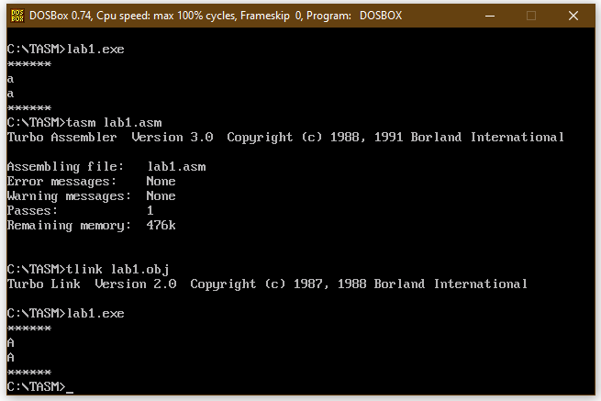**Output:**